**SCOA031 – Introduction to Database Systems - 2025**

**Question 1**: Given the following business scenario create an ERD using Unified modelling language. Clearly labelling **Primary keys** and **foreign keys**.

A salesperson may manage many other salespeople. A salesperson is managed by only one salespeople. A salesperson can be an agent for many customers. A customer is managed by one salespeople. A customer can place many orders. An order can be placed by one customer. An order lists many inventory items. An inventory item may be listed on many orders. An inventory item is assembled from many parts. A part may be assembled into many inventory items. Many employees assemble an inventory item from many parts. A supplier supplies many parts. A part may be supplied by many suppliers.

**Question 2:** Use the following entity to answer the following questions.

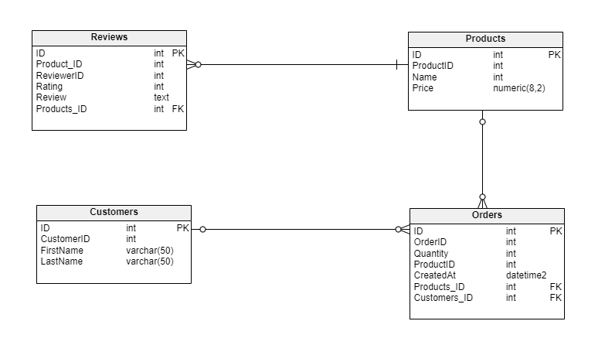

1. Create a relational schema for the entity “Reviews” and underline all the keys (3)
2. Create an Internal model for this entity.

**Question 3:**

1. Differentiate and discuss Entity integrity and Referential integrity.
2. Discuss the importance of business rules.

**Question 4:** Assume the following relations and answer the successive questions:

**Branch** (branch_name, branch_city)

**Customer** (customer_name, customer_city, customer_street)

**Account** (account_number, branch_name, balance)

**Loan** (loan_number, branch_name, amount)

**Depositor** (customer_name, account_number)

**Borrower** (customer_name, loan_number)

1. Find the loan number for each loan of an amount greater than $1200.
2. Find the names of all customers who have a loan at the Perryridge branch.
3. Find the names of all customers who have a loan, an account, or both from the bank.